PRDA-04 : JOB MARKET ANALYSIS

- Introduction
The Job Market Analysis project focuses on analyzing job-market data to identify employment trends, salary patterns, industry demand, company hiring patterns, job titles, required technical skills, and the relationship between salary and educational qualifications.
The dataset contains 742 job records and 42 features, including job title, salary estimate, company name, location, rating, headquarters, company size, industry, sector, revenue, skills, seniority, degree, state, and other job-related attributes.
The analysis aims to identify the most in-demand skills, qualifications, job responsibilities, and other job market patterns that can provide useful insights for job seekers and employers.

- Objectives of the Analysis
The main objectives of this project are:
- To identify the states having the highest number of job opportunities.
- To analyze minimum, maximum, and average salaries across different states.
- To identify the top industries with the highest number of Data Science-related job postings.
- To identify companies with the maximum number of job openings.
- To determine the most common job titles.
- To analyze salaries associated with the most common job titles.
- To identify the technical skills required by companies for different job titles.
- To analyze the relationship between average salary and educational qualifications.
- To analyze the available features and derive additional insights.
- To visualize the findings using Power BI and provide insights and suggestions based on the analysis.

- Dataset Overview
Attribute | Description
Number of Rows | 742
Number of Features | 42
Dataset Domain | Job Market Analysis
Salary (Unit) | USD
Salary Measure | Average salary in thousands (K)
Main Job Information | Job Title, Salary, Company, Location
Company Information | Rating, Size, Founded, Industry, Sector, Revenue
Skill Information | Python, Spark, AWS, Excel, SQL, SAS, Keras, PyTorch, etc.
Education | Degree
Seniority | Seniority_by_title
Location | State / Job location

- Data Cleaning and Preparation
  - Verified the dataset size
Checked the dataset to ensure it contained the expected 742 rows and 42 columns.
  - Reviewed the column structure
Reviewed all 42 columns and confirmed that the required job, salary, company, location, industry, skill, and education-related fields were available.
  - Checked data types
Reviewed the data types of the columns and ensured that numerical fields such as salary, rating, age, and skill indicators were suitable for analysis.
  - Reviewed unnecessary fields
Examined the available columns and retained the fields relevant to the assigned analysis and Power BI visualizations.
  - Handled missing values
Identified missing or null values in the dataset and handled them appropriately during the cleaning process.
  - Checked duplicate records
Reviewed the dataset for duplicate records to maintain data consistency.
  - Cleaned text fields
Reviewed text-based fields such as Job_Title, Company_Name, Industry, Location, Degree, and State for consistency.

  - Validated salary-related fields
Checked Lower_Salary, Upper_Salary, and Avg_SalaryK to ensure that salary information was in a usable format for analysis.
  - Validated location/state information
Reviewed the State field and standardized the values where required so that state-wise analysis could be performed correctly.
  - Verified skill fields
Reviewed the skill indicator columns such as Python, Spark, AWS, Excel, SQL, SAS, Keras, PyTorch, Scikit-learn, TensorFlow, Hadoop, Tableau, BI, Flink, MongoDB, and Google Analytics.
  - Final data validation
After cleaning, verified that the final dataset contained 742 rows and 42 columns.
  - Prepared the cleaned dataset for analysis
Exported the cleaned dataset and imported it into MySQL Workbench for performing the required analysis.
Data Cleaning Tool: I used Power BI to clean and prepare the dataset. After completing the cleaning process, the validated dataset containing 742 records and 42 columns was prepared for further analysis in MySQL Workbench.

- Analysis & Findings
  - States with the Most Job Opportunities
The number of job postings was analyzed across different states to identify locations with the highest demand for job opportunities.
According to the analysis, CA has the highest number of job postings, with 152 jobs. The next highest states are MA, NY and VA. This indicates that these states have a relatively higher concentration of opportunities within the dataset.

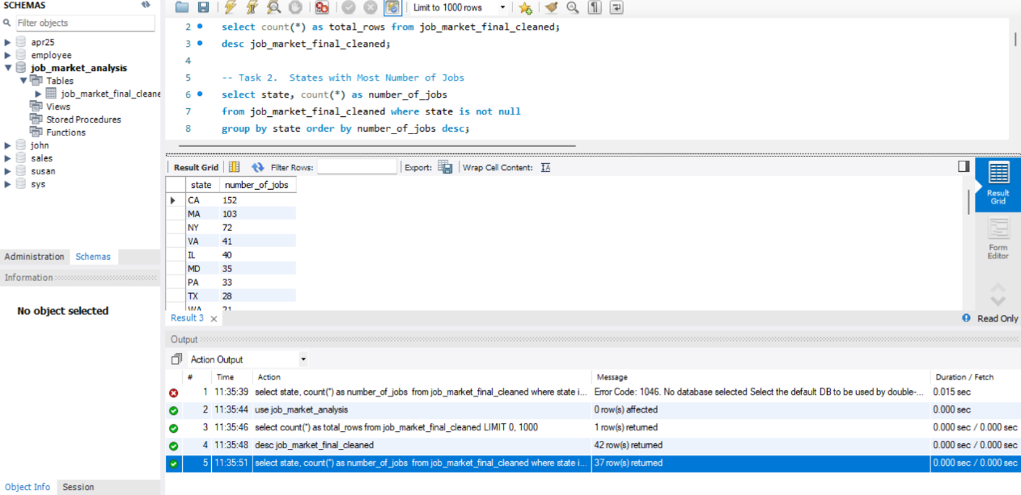
Fig 5.1 Jobs by State
  - Average Minimum and Maximum Salaries by State
The lower and upper salary ranges were analyzed across states to understand differences in salary expectations. The state with the highest average minimum salary is CA, with an average minimum salary of $92K. The state with the highest average maximum salary is CA, with an average maximum salary of $155K. The results indicate that salary ranges vary considerably across locations, suggesting that geographical location can influence compensation levels.

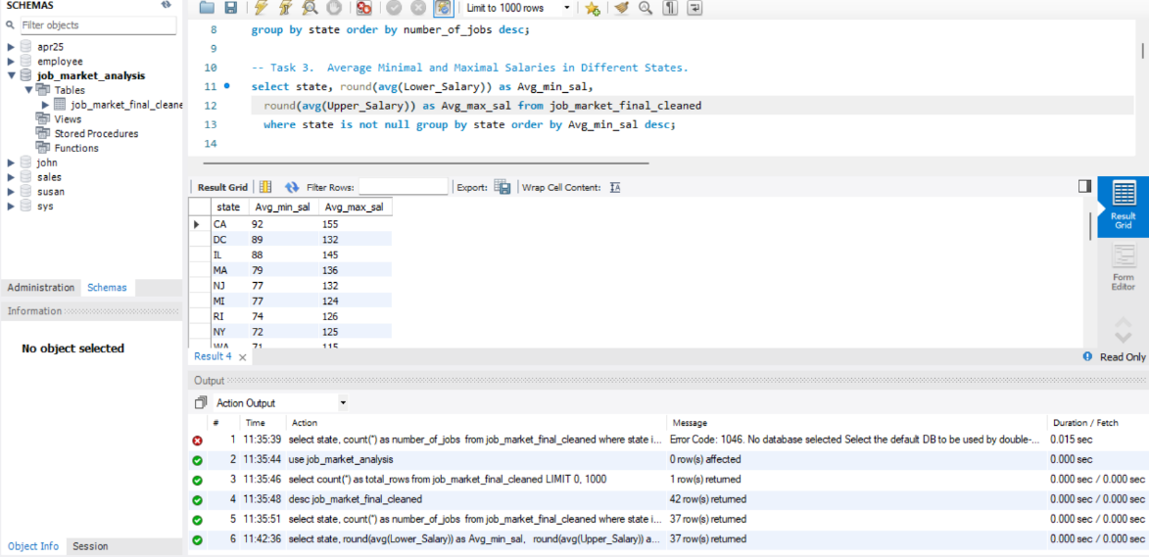
Fig 5.2 Average Minimum and Maximum salaries by State

  - Average Salary by State
The average salary was calculated for each state using the Avg_SalaryK field. CA recorded the highest average salary of approximately $124K, while NE recorded the lowest average salary of approximately $54K. This comparison helps identify locations where job opportunities offer relatively higher average compensation.
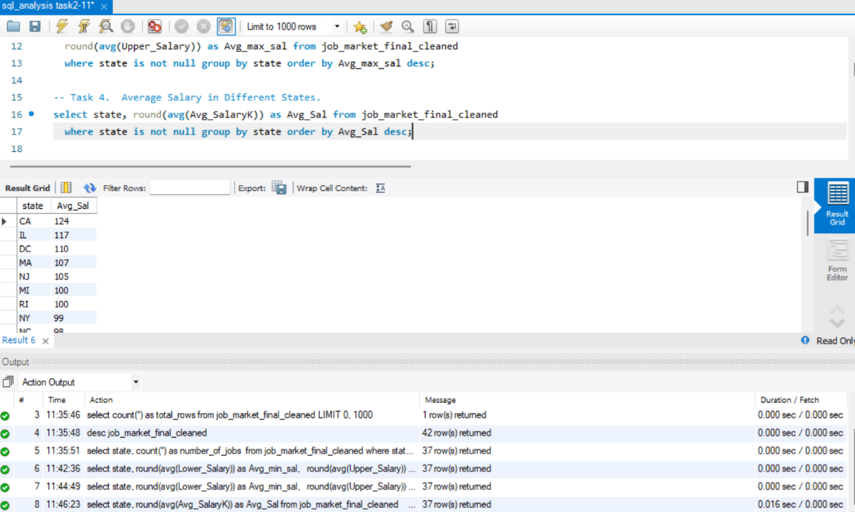
Fig 5.3 Average Salary by State
  - Top 5 Industries with Data Science-Related Job Postings
The industry field was analyzed to identify the five industries with the highest number of Data Science-related job postings.
These industries represent the areas with the highest demand for the analyzed job profiles within the dataset.

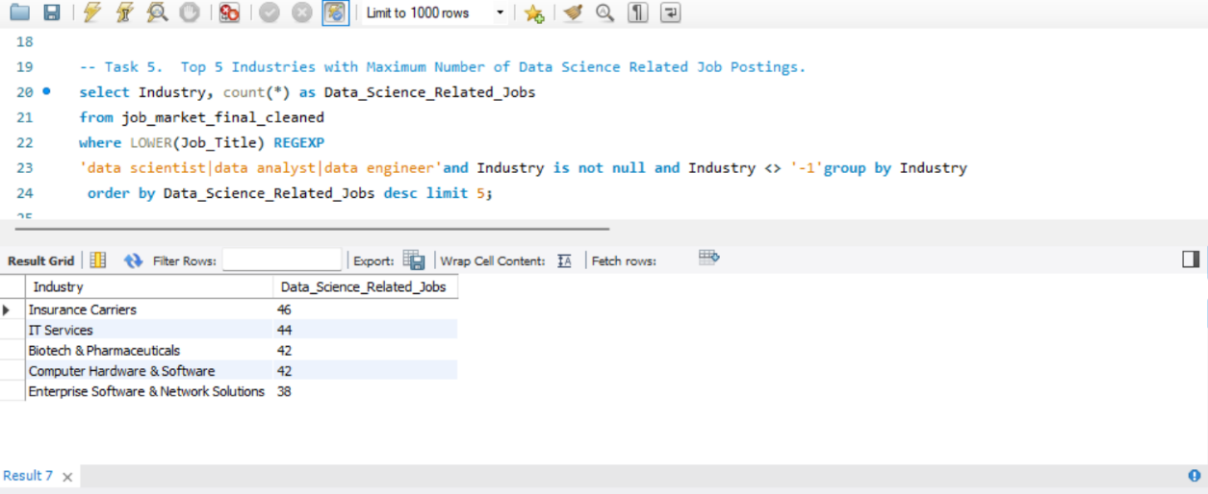
Fig 5.4 Top 5 Industries with Data Science related Job postings

  - Companies with Maximum Job Openings
Company-wise job postings were analyzed to identify organizations with the highest number of openings. The company with the highest number of job postings is Takeda Pharmaceuticals, with 14 openings. Other companies with a high number of openings include MassMutual, Reynolds American and Software Engineer Institute. This indicates that these organizations have a comparatively higher hiring presence in the dataset.

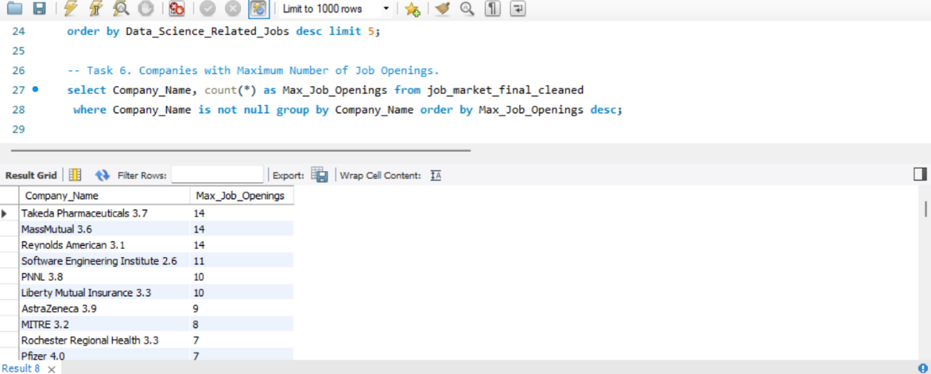
Fig 5.5 Top Companies by Job Openings

  - Job Titles with Most Number of Jobs
Job titles were analyzed to determine which positions occur most frequently in the dataset. The most frequently occurring job title is Data Scientist, followed by Data Engineer, Senior Data Scientist, and Data Analyst. The results indicate the job roles that have the highest representation in the analyzed job market.
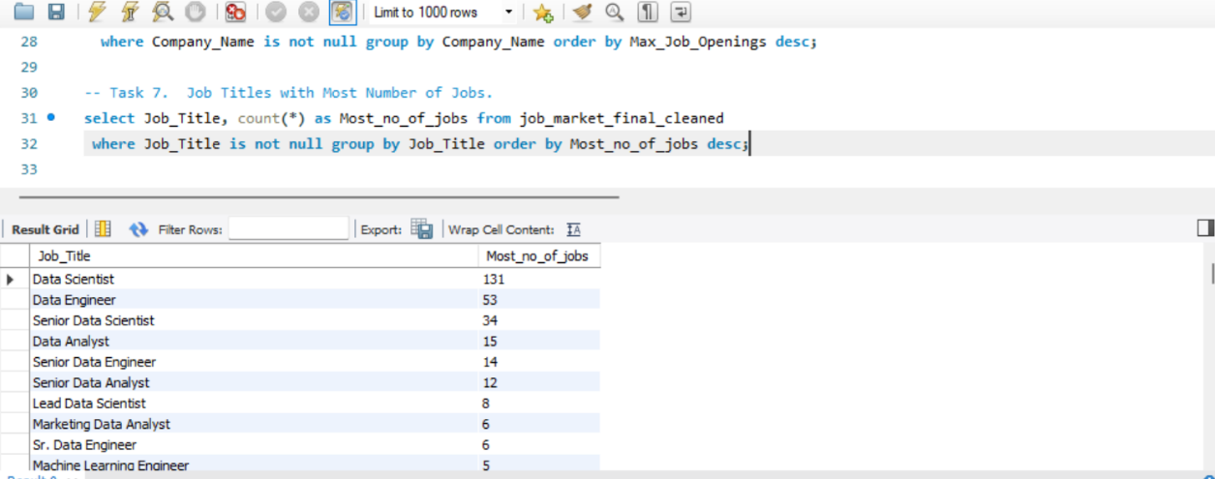
Fig 5.6 Top Job Titles by Number of Jobs

  - Salary of Job Titles with Most Jobs
The average salary of the most frequently occurring job titles was analyzed using the Avg_SalaryK field. Among the most common job titles, Data Scientist has an average salary of approximately $106K, while Data Engineer has an average salary of $92K. The comparison shows that job demand and salary level do not necessarily follow the same pattern; a frequently occurring role may not always have the highest average salary.
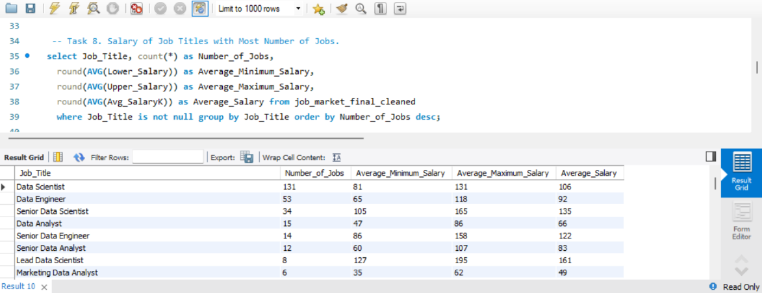
Fig 5.7 Average Salary by Top Job Titles

  - Skills Required by Companies for Each Job Title
The skill-related fields were analyzed to identify the technical skills most frequently required by companies. This analysis highlights the technical capabilities that are most relevant to the job market represented by the dataset.

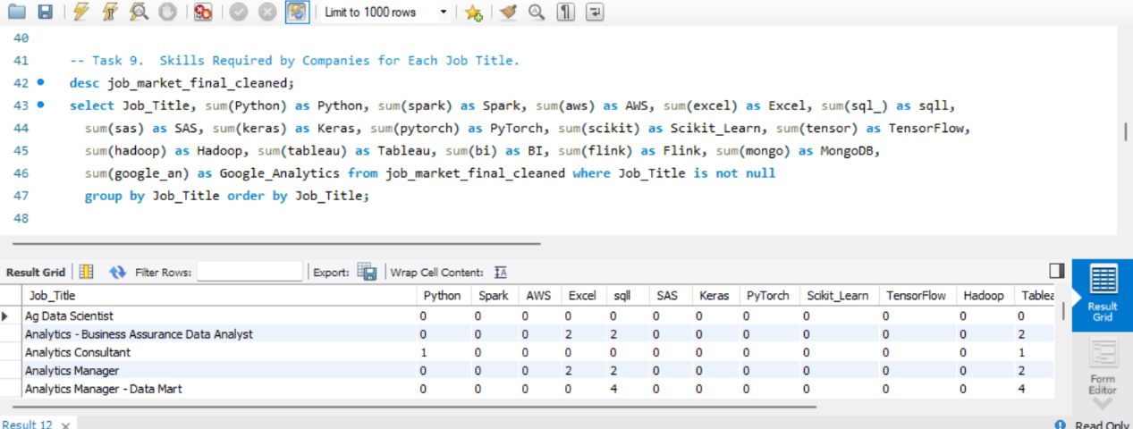
Fig 5.8 Most In-Demand Skills

  - Relationship Between Average Salary and Education
The relationship between educational qualification and average salary was analyzed using the Degree and Avg_SalaryK fields. The results show that P has the highest average salary of approximately $116K, while na has an average salary of approximately $95K. However, the analysis represents associations within this dataset and should not be interpreted as proof that educational qualification alone causes higher or lower salaries.

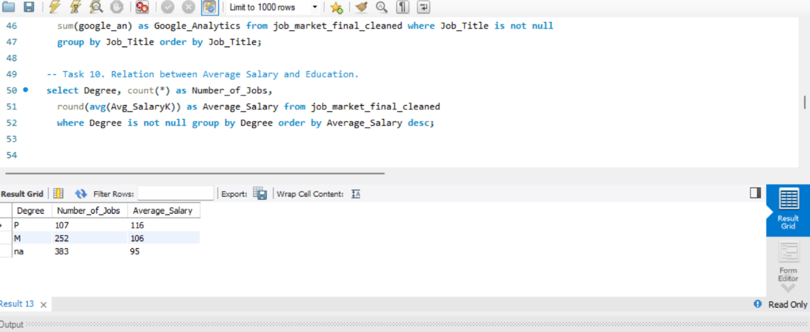
Fig 5.9 Average Salary by Education level

- Additional Insights
  - Most Common Jobs Locations
The analysis of job locations shows that CA (California) has the highest number of job postings, with 152 jobs, followed by MA (Massachusetts) with 103 jobs and NY (New York) with 72 jobs. VA (Virginia) and IL (Illinois) have 41 and 40 job postings, respectively. This indicates that job opportunities in the analyzed dataset are highly concentrated in a few locations, with California having the largest share among the top five locations.
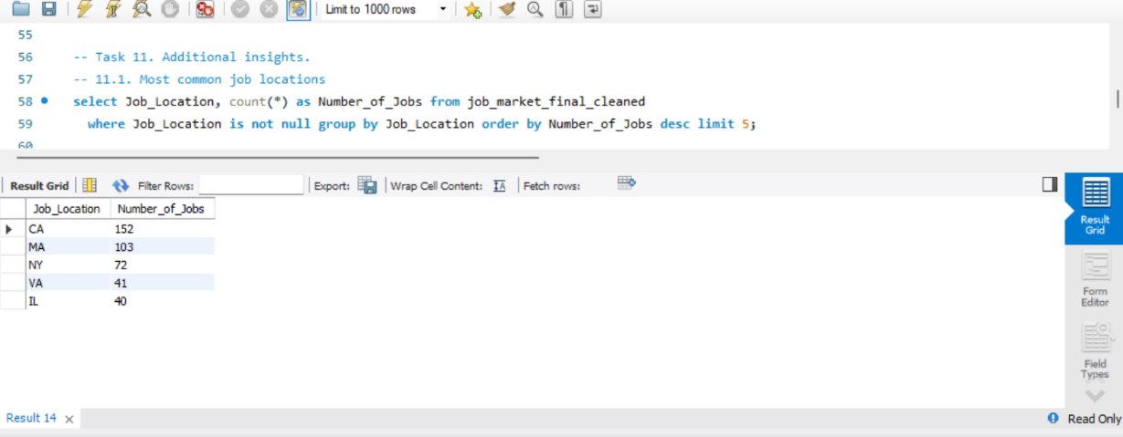
Fig 6.1 Most common job locations

  - Highest paying States
The analysis shows that California (CA) has the highest average salary among the states analyzed, with an average salary of $124K, based on 152 job postings. Illinois (IL) ranks second with an average salary of $117K, followed by Washington, D.C. (DC) at $110K. Massachusetts (MA) and New Jersey (NJ) have average salaries of $107K and $105K, respectively.
Other states such as New York (NY), North Carolina (NC), Maryland (MD), Virginia (VA), and Pennsylvania (PA) also show relatively high average salaries, ranging from $94K to $99K. And the lowest paying state is WI.
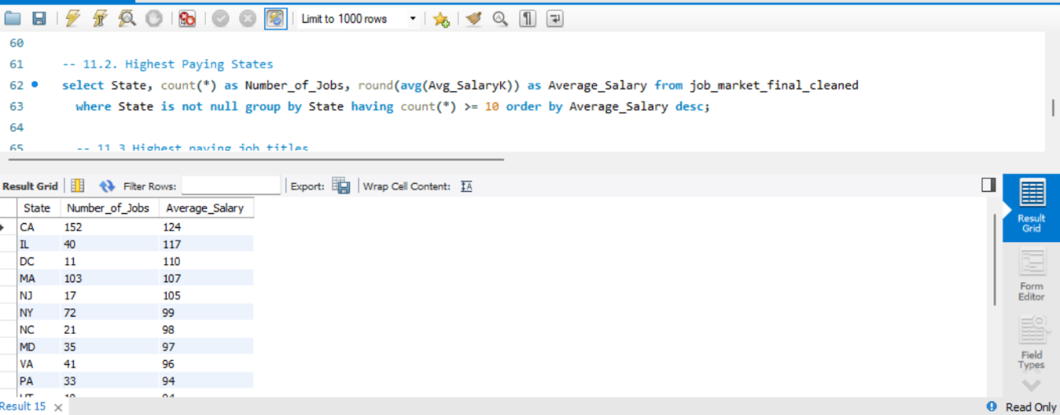
6.2 Highest paying states

  - Highest paying Job Titles
The analysis shows that Principal Data Scientist has the highest average salary among job titles with at least 5 job postings, with an average salary of $176K across 5 postings. It is followed by Lead Data Scientist at $161K and Senior Data Scientist at $135K. Senior Data Engineer and Sr. Data Engineer have average salaries of $122K and $115K, respectively. The Data Scientist role has the highest number of postings among these higher-paying roles, with 131 job postings, and an average salary of $106K. Among the job titles, Marketing Data Analyst has the lowest average salary at $49K.
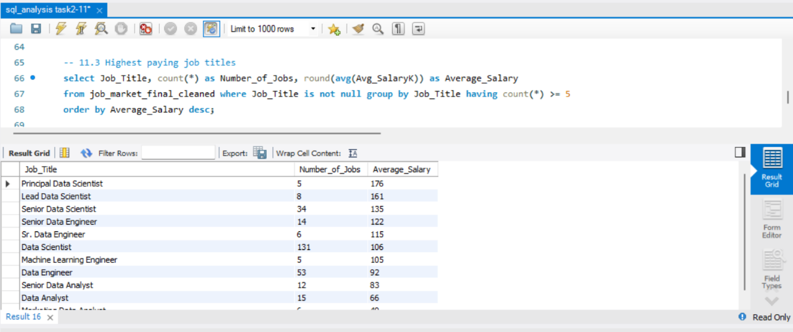
Fig 6.3 Highest paying Job Titles

  - Salary by Seniority
The analysis shows that Senior (sr) positions have the highest average salary of $122K, with 220 job postings. Non-senior (na) positions account for the largest number of postings, with 519 jobs, and have an average salary of $93K. Junior (jr) positions have the lowest average salary of $71K, with 3 job postings.
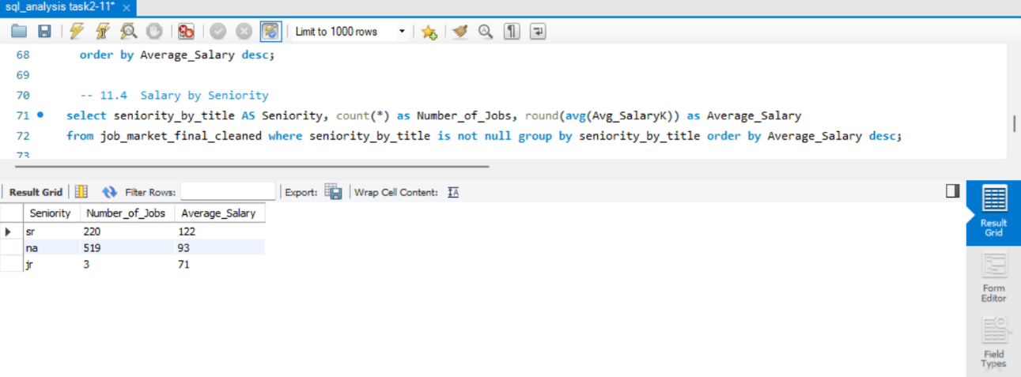
Fig 6.4 Salary by seniority

  - Overall Salary Statistics
The analysis of all 742 job postings shows that the average minimum salary is $75K, while the average maximum salary is $128K. The overall average salary across the dataset is $101K. The average salary values range from a minimum of $15.5K to a maximum of $254K.
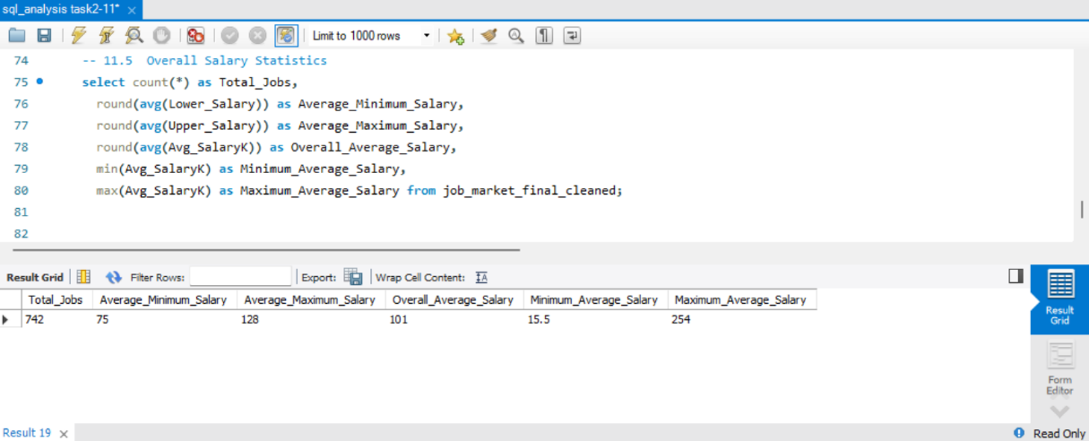
6.5 Overall salary statistics

- Power BI Visualization
Power BI was used to visualize the results of the job-market analysis. The dashboard provides an interactive representation of job availability, salary patterns, industries, companies, job titles, skills, and educational qualifications. The dashboard includes key performance indicators and charts for analyzing the distribution of job postings and salary patterns across different dimensions.

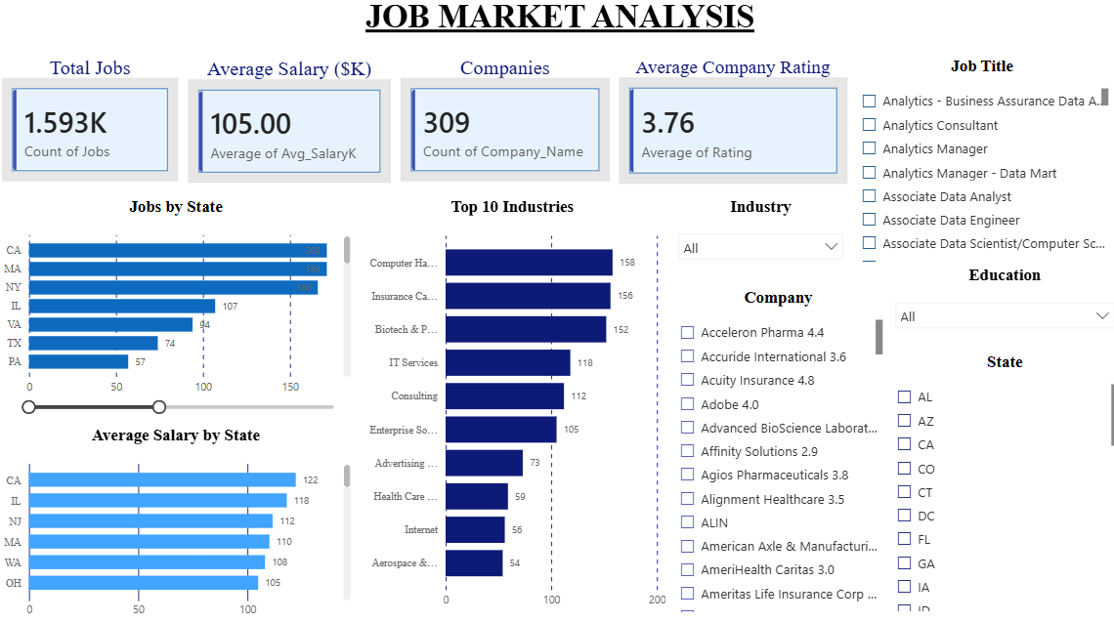
Fig 7.1 Job Market Analysis – Executive Overview

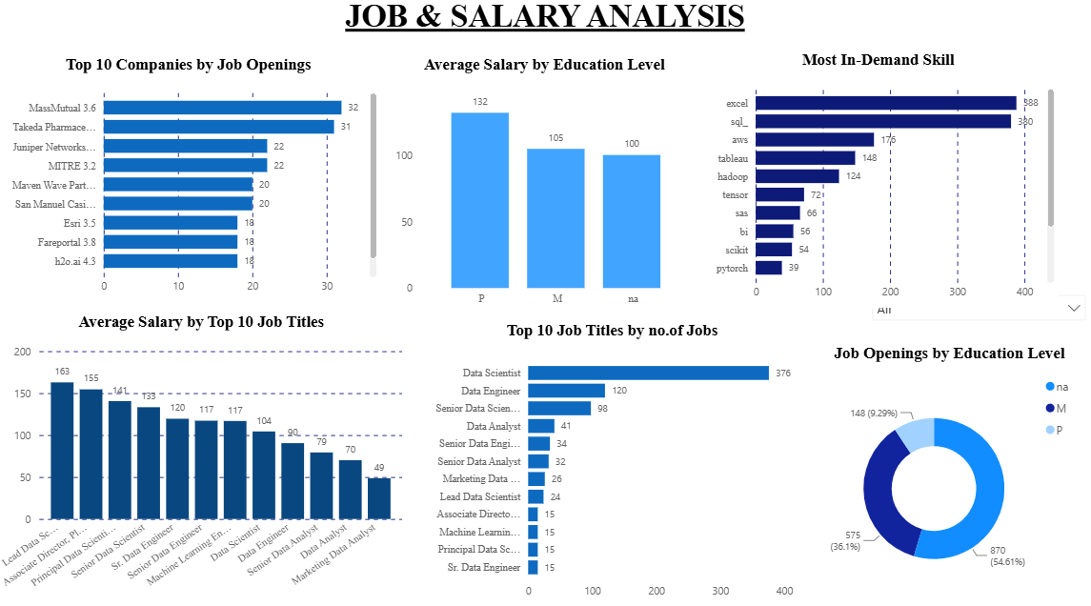
Fig 7.2 Job Market Analysis – Jobs, Salaries & Skills

- Inputs / Suggestions to the Company
  - Focus recruitment on high-demand locations
The company can prioritize recruitment and talent acquisition in states with a higher concentration of relevant job postings, as these locations indicate stronger market activity.
  - Align compensation with market conditions
Salary packages can be benchmarked against average salaries for similar roles and locations to remain competitive in attracting qualified candidates.
  - Develop role-specific skill requirements
Job descriptions should clearly identify the technical skills required for each position so that organizations can attract candidates with the appropriate capabilities.
  - Consider education and experience together

Educational qualifications should be considered along with relevant skills, experience, and job requirements when evaluating candidates and designing compensation structures
  - Monitor industry hiring trend
Organizations can continuously monitor industries with increasing job demand to identify emerging hiring opportunities and skill requirements.

- Conclusion
The Job Market Analysis provided an overview of employment opportunities, salary patterns, industry demand, company hiring activity, job titles, technical skills, and educational qualifications within the dataset. The analysis identified the states and industries with higher job demand, companies with greater numbers of job postings, frequently occurring job titles, commonly required technical skills, and variations in salary across locations, job roles, and educational levels.
The Power BI dashboard provides an interactive way to explore these patterns and supports the identification of important trends in the job market. The findings can help employers understand market demand, salary expectations, and skill requirements while also providing useful information for job seekers.
Overall, the analysis demonstrates how structured job-market data can be used to identify employment trends and support data-driven recruitment and workforce decisions.

